(Approx. 1660 words)

LibreOffice – a Free Office Suite
By Joel Ewing, President, Bella Vista Computer Club, AR
April 2018 issue, Bits & Bytes
http://www.bvcompclub.org/
president (at) bvcompclub.org

Almost everyone today that is computer savvy has heard of, or is even a user of, one or more of the classic components of the Microsoft Office Suite: Word, Excel, PowerPoint, & Access. Although there are competing products, the MS Office products are still the purchase choice for many businesses.

For occasional personal use, the purchase cost of MS Office is more than some care to spend on a software package. Microsoft is now trying to attract new users by moving MS Office Suite users from a purchase model to a leasing model under Office365, providing access to local computer and cloud-based Office products for a monthly fee (around $70 to $150 annually). This makes for a lower up-front cost and includes automatic upgrades to new versions, but in the long run that approach will be more expensive for the user than a one-time purchase of software if you plan to use it for many years.

Over the last several decades there has been an evolution in the availability of free, open-source alternatives to the components of MS Office. What started as just a free word processing application, Star Writer, evolved into StarOffice, and then later into OpenOffice, which then fractured into two projects, Apache OpenOffice and LibreOffice, that have evolved somewhat differently from the same initial code. Both OpenOffice and LibreOffice are currently available and still have much in common, but they are distributed under different “public” software licenses, which makes LibreOffice easier to enhance and thus slightly more attractive. Yes, even free software must have a license, to ensure that the freely accessible source code people have donated to the project continues to be free and is not exploited for profit in ways the donors did not intend. The main components of LibreOffice are Writer (the word processing counterpart to MS Word), Calc (the spreadsheet counterpart to MS Excel), Impress (the presentation counterpart to MS PowerPoint), Base (partial database counterpart to MS Access), and Draw (similar to MS Paint?).
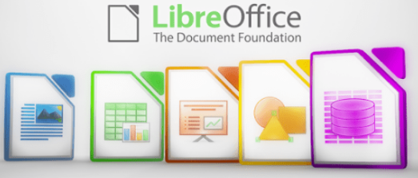
There are also some significant sub-components, Math for writing mathematical equations, and Chart, which is used to generate charts for documents and spreadsheets. Base is not a complete database application, because it is designed to interface with other free database systems, like MySQL or mariadb, that provide the actual database storage and query support. Base provides an interface to manage an external database, or to use a spreadsheet as if it were a database, and to allow the other LibreOffice components to access information from a database (for example, in a mail merge operation).

LibreOffice is available for MS Windows, Mac OS, and Unix/Linux platforms. The look, feel, and functionality of the applications are the same (within limitations of desktop differences) across all platforms. This gives LibreOffice (and OpenOffice) an advantage over MS Office, as there is no native-Unix version of MS Office. There are ways the Windows version of MS Office can be run under Unix/Linux, but they are a little kludgy and the simplest method for running MS Office on Linux (wine) frequently has some compatibility issues with the newest versions of MS Office.

The LibreOffice applications have their own native file formats (ODP, ODT, ODS), but can also read and write files in MS Office formats (PPTX, DOCX. XLSX, etc.) as well as other formats. The current MS Office products also contain support for the LibreOffice file formats, support that was lacking in some of the older MS Office versions. This means you can probably generate files from LibreOffice (in either native or MS Office formats) that can be successfully viewed by someone with a later version of MS Office, but if you suspect they may have an older version of MS Office, you may need to save it in an appropriate older MS Office file format. The later MS Office versions have similar cross application support with the Open Source formats used by LibreOffice. Be aware, however, that while there is pretty good compatibility, it is not 100%. There are some features in LibreOffice that have no counterparts in MS Office, and vice versa. You will generally end up with a document that is readable, but there may be some subtle and sometimes not so subtle differences in appearance that might require additional editing to get a polished result. Past experience suggests the MS Office applications may do a more accurate conversion to/from LibreOffice file formats than LibreOffice does converting to/from MS Office formats – quite possibly because MS formats are proprietary and public documentation is lacking. Also, the proprietary fonts available in MS Office do not have exact matches in LibreOffice, and subtle differences in character sizes may change where line splits, column splits, or page splits occur in text.

This means that if you have carefully formatted a document for a formal presentation, and you know the document will be used under a different office suite than was used to create it, you really want to test the document under the targeted office suite to see if any format changes are required. Positioning of images within a document may shift, which in turn will affect how text flows around the image. I have seen cases going between Impress and PowerPoint where images covered up text or font size changed to the point that text ended up outside the normal slide viewing area . A presentation might convert OK, but then in other cases you could have some marginally viewable slides. This is particularly true if the target display system only has the old free PowerPoint viewer, which hasn’t been updated for several years and only claims to support files from PowerPoint 2010 and earlier versions. Similar caveats apply whenever you intend to “publish” a polished, formal document: the final editing should be done on the office suite on which the document will be published or presented.

Note that all these issues of formatting compatibility disappear if your goal is not to distribute an editable version of the document but just a PDF (Portable Document Format) version of the document. Both MS Office and LibreOffice will export documents as a PDF file that accurately reflects the way that office suite displays the document, including consistent positioning of text and objects on each page.

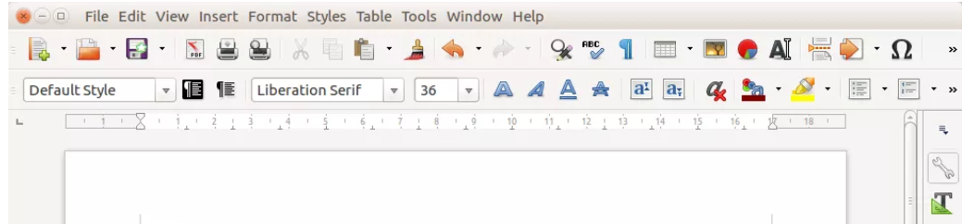
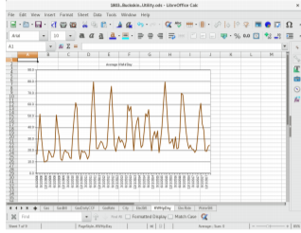
I use LibreOffice Writer and Calc extensively, probably multiple times every day; and Impress multiple times monthly. This article was
composed using Writer, as was the entire BVCC Newsletter. I use Calc to manipulate membership rosters, to track home utility usage patterns and utility rates, and to manage a few other tables of various types. I use Impress for all my class and general meeting presentations. I occasionally use MS Word, primarily to proofread a Newsletter for another organization, precisely because there are fonts used that have issues with LibreOffice – that need could probably even be avoided if I also requested the document as a PDF file and used the PDF version to proofread the line/column/page breaks and font appearance. I rarely use PowerPoint or Excel except when checking out how their capabilities differ from Impress and Calc, or to confirm that a file that LibreOffice finds “broken” has similar problems with MS Office. I routinely use LibreOffice to read and update MS Word and Excel file formats that are shared with others, and only rarely do I encounter issues where I find it expedient to resort to using MS Office (like the Newsletter font issue mentioned earlier).

The user interfaces of MS Office and LibreOffice are significantly different. MS Office has many more different action icons and has “ribbons” of icons. LibreOffice relies more on traditional menu and sub-menu selections. Which approach is easier to use is a matter of personal preference. Both have context-sensitive menus in response to a right-click within a document. In most cases there is identical functionality in MS Office and LibreOffice, but the place and manner of invoking the functionality differs. There are some areas where the MS Office applications are better and others where LibreOffice is better. I have yet to find something I wanted to do that I couldn’t do with LibreOffice, but in some cases on-line research was necessary, and in other cases a change in approach was required.

MS Office by default provides more templates and “cute” backgrounds – if you like that sort of thing – to use for creating documents. LibreOffice has fewer built-in backgrounds, but if you have other image manipulation tools, you can create your own custom backgrounds and add them. There are also some LibreOffice addons that can be downloaded and installed that I haven’t yet tested.

My impression is that there may be more “bugs” in LibreOffice than in MS Office, but that could be because I use it more. I’ve always been able to find ways to work around them. For example, the documentation implies that in a Writer document you should be able to format some pages as multi-column and other pages as single-column; but it doesn’t work as documented – it always changes the number of columns globally for all pages. One circumvention I’ve used is to just use single column format for the entire document, define a large “frame” within the pages you want to be multi-column, and then define the internal structure of text within that frame as multicolumn. Moving images within a document sometimes does strange things – it’s sometimes necessary to delete it from the original location and re-insert it at the desired location. There always seems to be a way to get the desired effect, it sometimes just requires on-line research (and as a less frequent user of MS Office, I find I also must do similar research to find how to do some things in MS Office).

LibreOffice is an incredibly useful suite of applications, and you can’t beat the price. It can be downloaded from https://www.libreoffice.org/

